**CHAPTER 1**

**Python Setup**

# Installing Python on Windows 10:

1. Go to [www.python.org](http://www.python.org/)
2. Click “Downloads” Link at the top of the page

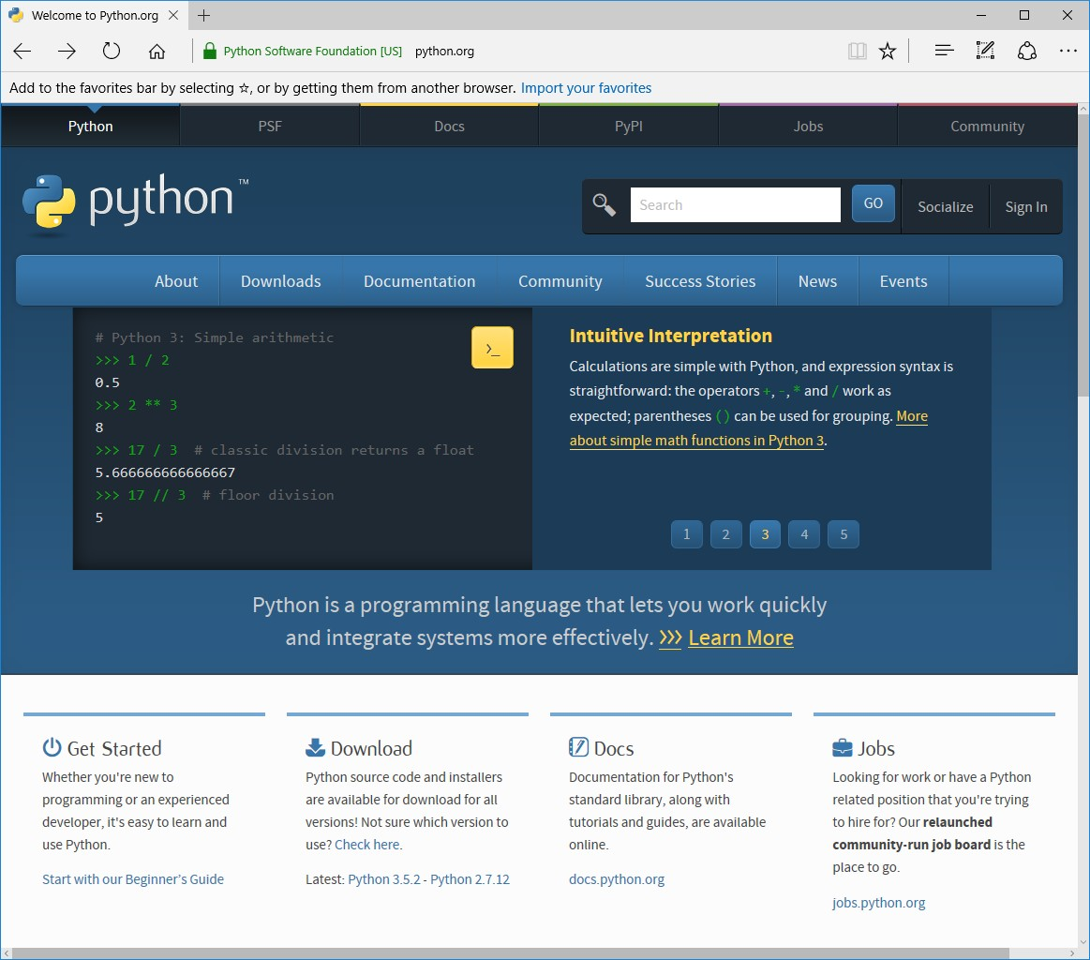

1. Click “Download Python 3.5.2” (or whatever the 3.X version currently is:

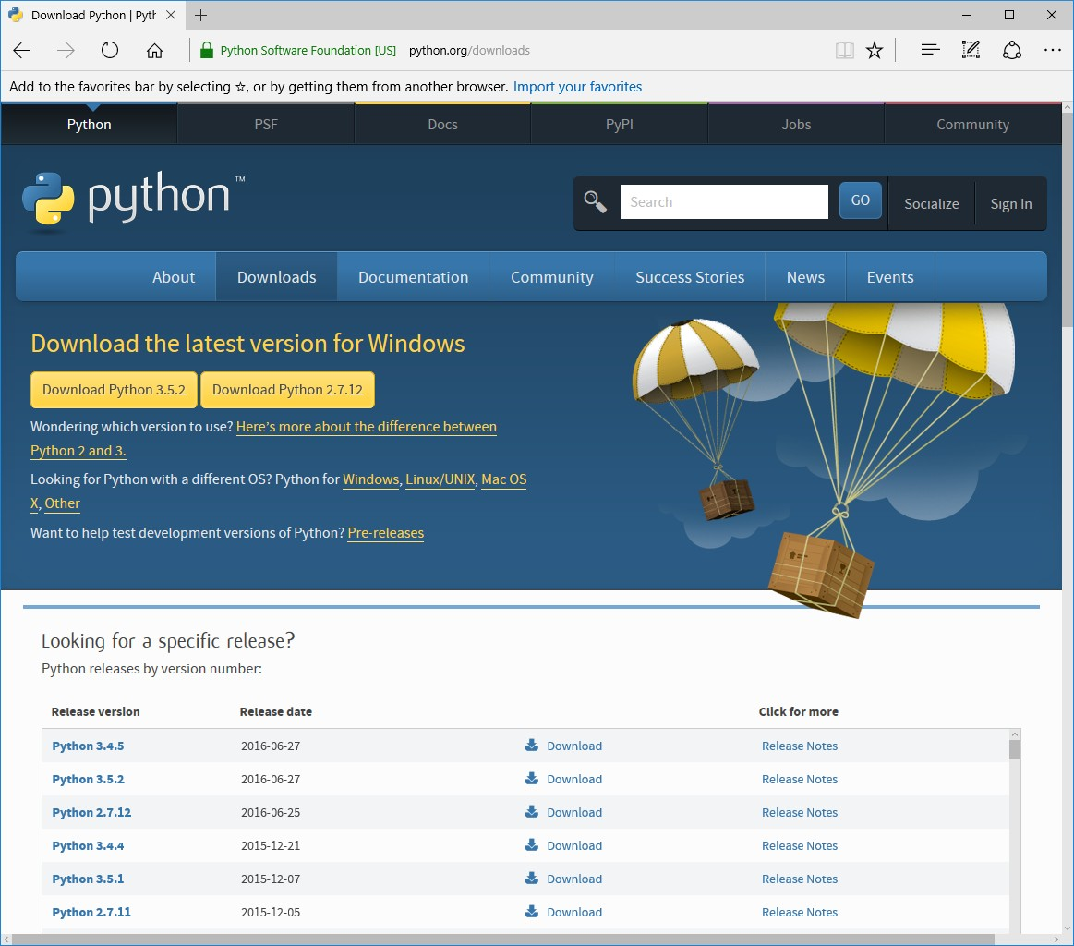

1. When it asks you, “What do you want to do with python-3.5.2.exe (27.9 MB)?”, click “Save” then “Run”

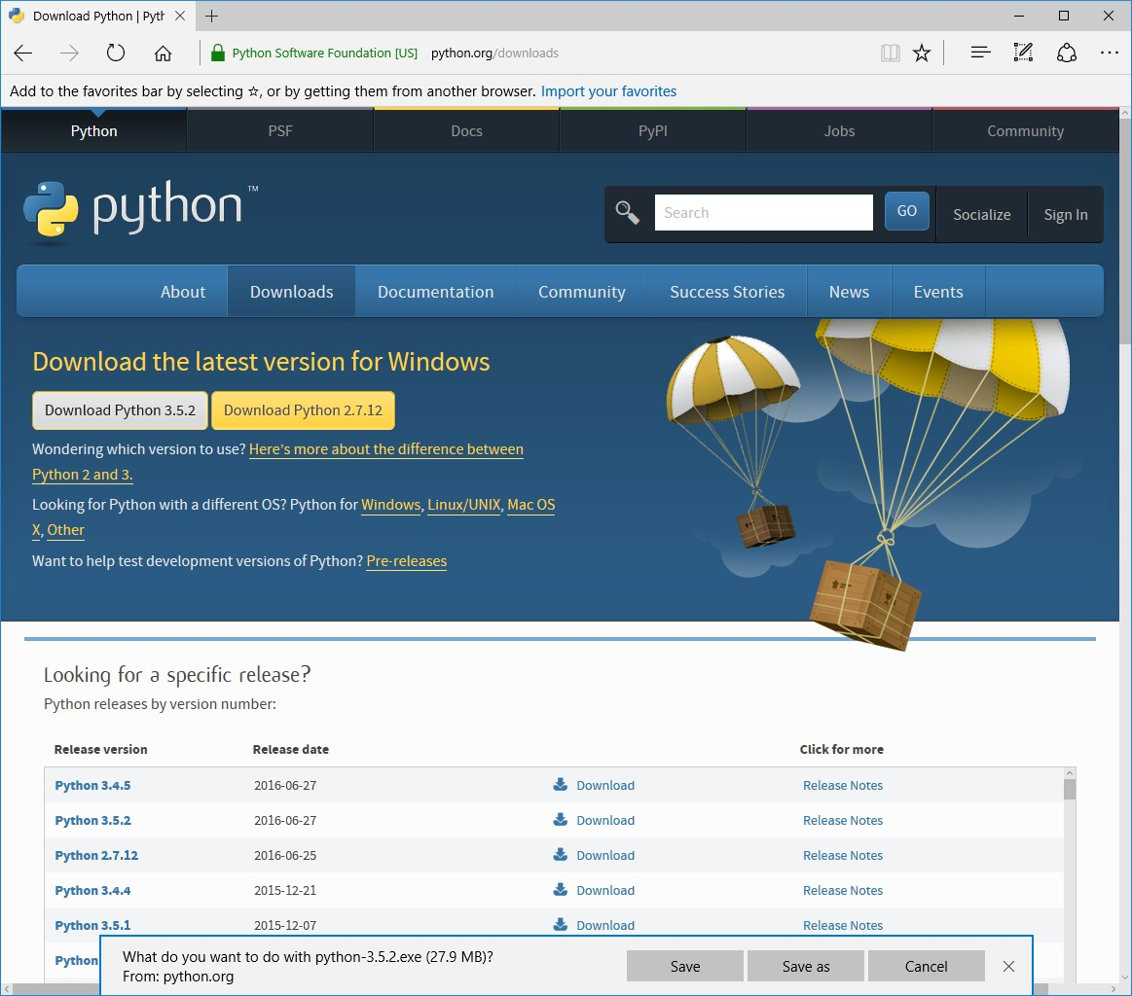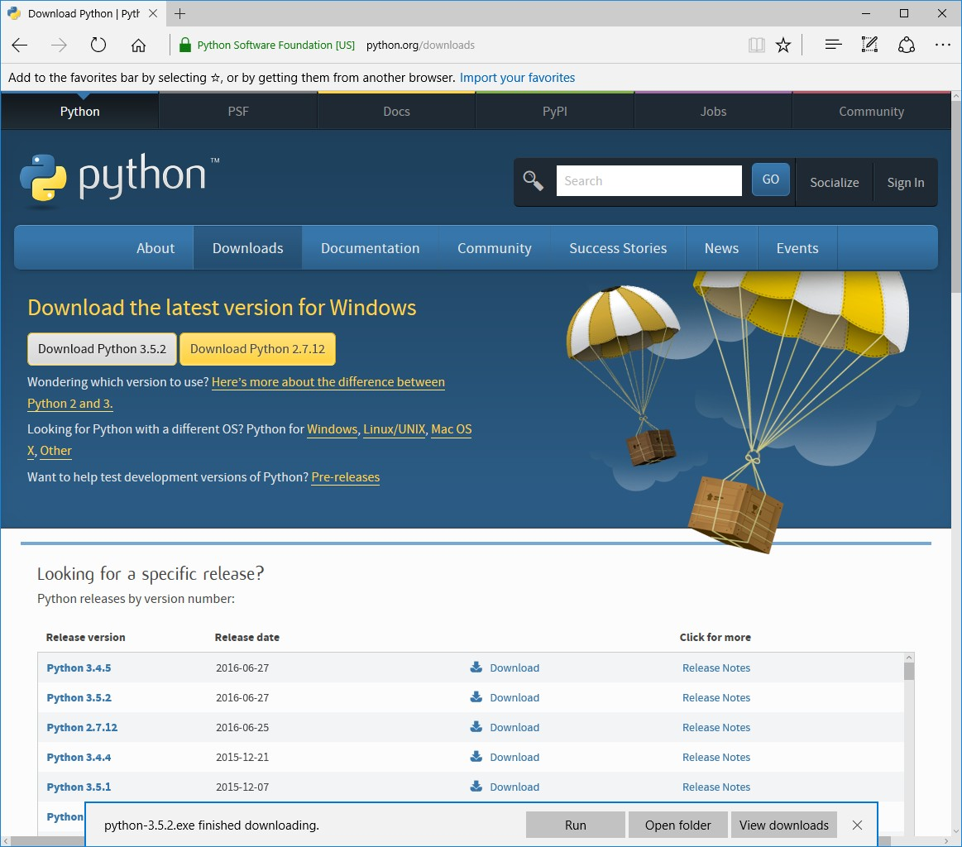

1. When the installation window comes up, click “Install Now”
   1. You can choose to check the “Install launcher for all users (recommended) or not – either way should be OK
   2. You can choose to “Add Python 3.5 to PATH” or not – either way should be OK
   3. Note: Depending on how Windows is set up, you might need to provide an administrator password to install on your system at this point.
   4. You can choose to “Customize Installation” if you want, especially if you want to install to a location other than the default one shown. Generally I recommend installing to the default location unless you have a problem doing so.
   5. In any case, you might want to note the location of the installation in case you have difficulty later. If you are specifying the location yourself, put it in a location you are likely to easily find/remember.

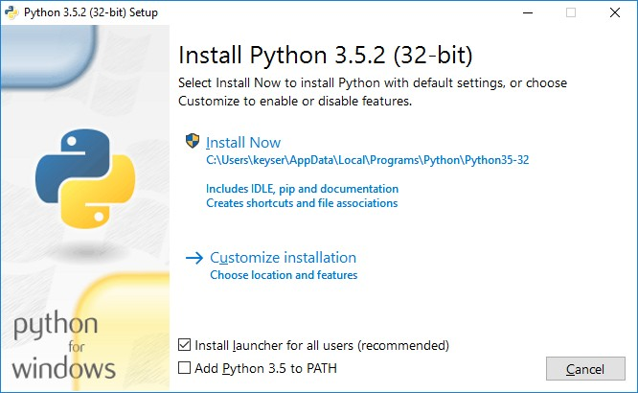

1. You should see Python installing at this point. When it finishes, you should see a screen that says the installation was successful. You can click “Close”

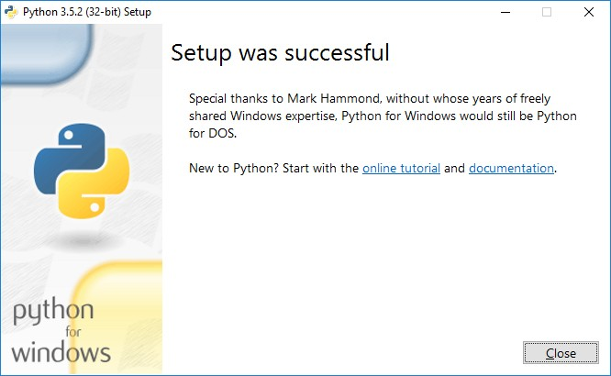

# Running Python:

Now you have installed Python. That means you will be able to run Python files and use the IDLE Python editor on your computer. If you want to test this quickly, you can do the following:

1. Go to the text box at the lower left of your Windows desktop and type in “IDLE”. You should see a program come up from the search that says “IDLE (Python 3.5 32-bit) Desktop app” show up. Click on this.
2. You should now have the “IDLE” Python shell, that looks like this:

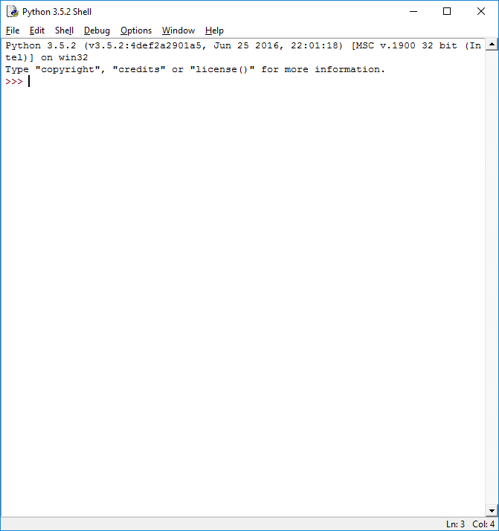

1. Try typing in a short python command, like:
   1. a math operation: 1+1
   2. a print statement: print(‘Hello, World!’) It should give you the result:

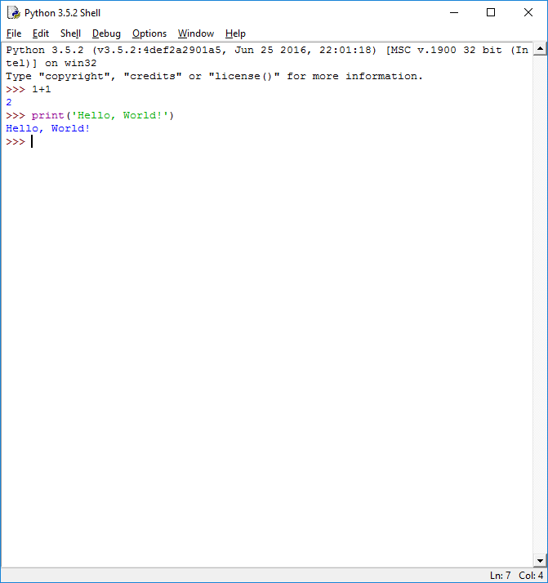

Now you are ready to install the PyCharm Integrated Development Environment (IDE).

# Installing PyCharm

1. Go to [www.jetbrains.com/pycharm](http://www.jetbrains.com/pycharm)
2. Click the “Download” button at top left (you can also scroll down the page and click the download link for the community version directly)

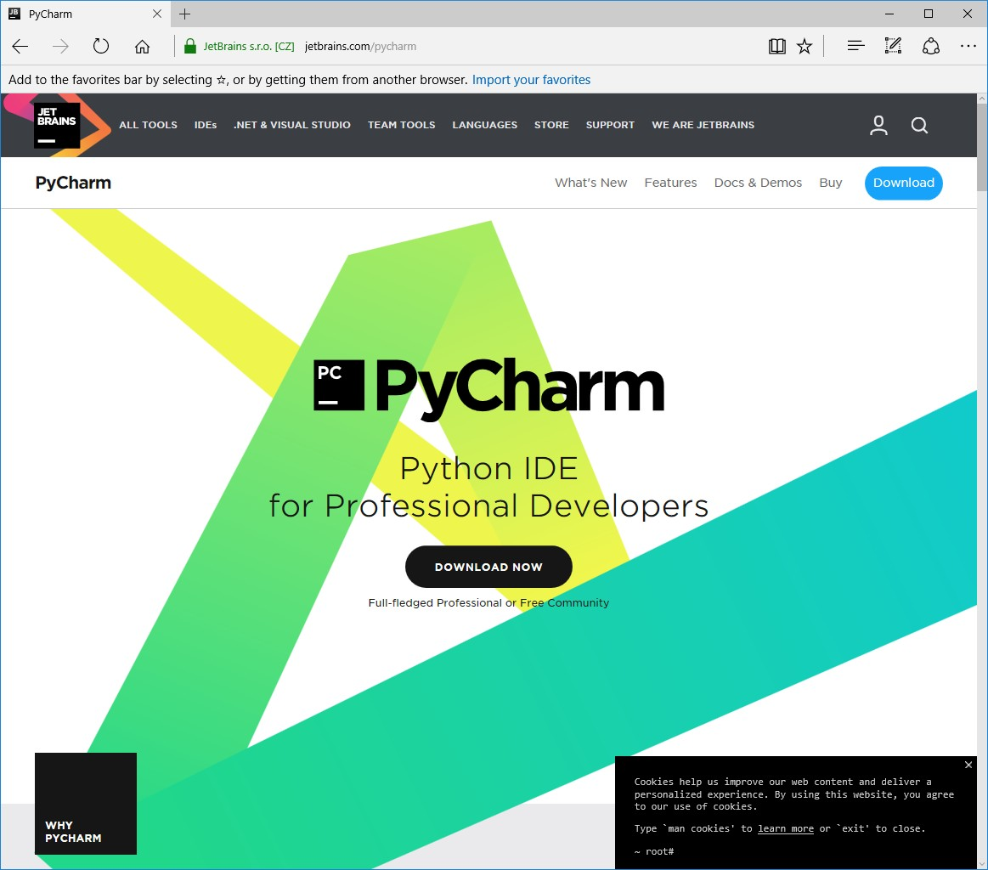

1. Click the “DOWNLOAD” link under the Community edition

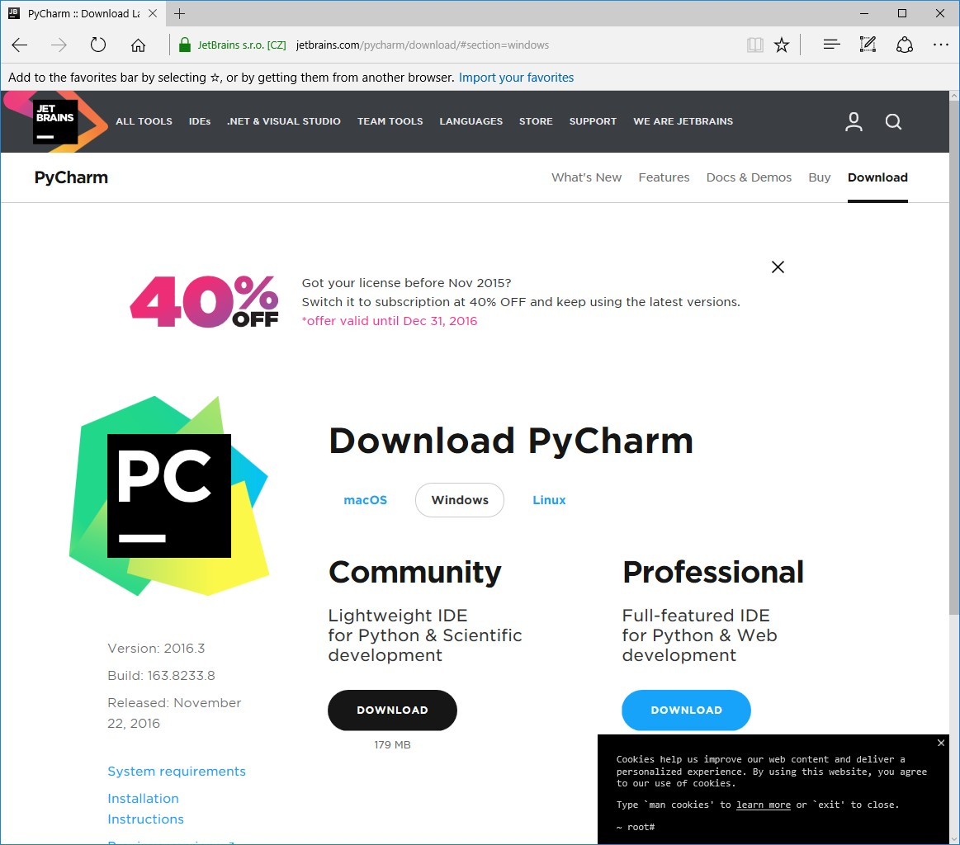

1. When the download box pops up, click “Save” and then “Run”.
   1. Depending on your computer’s setup, you might need to enter an administrator password at this point.

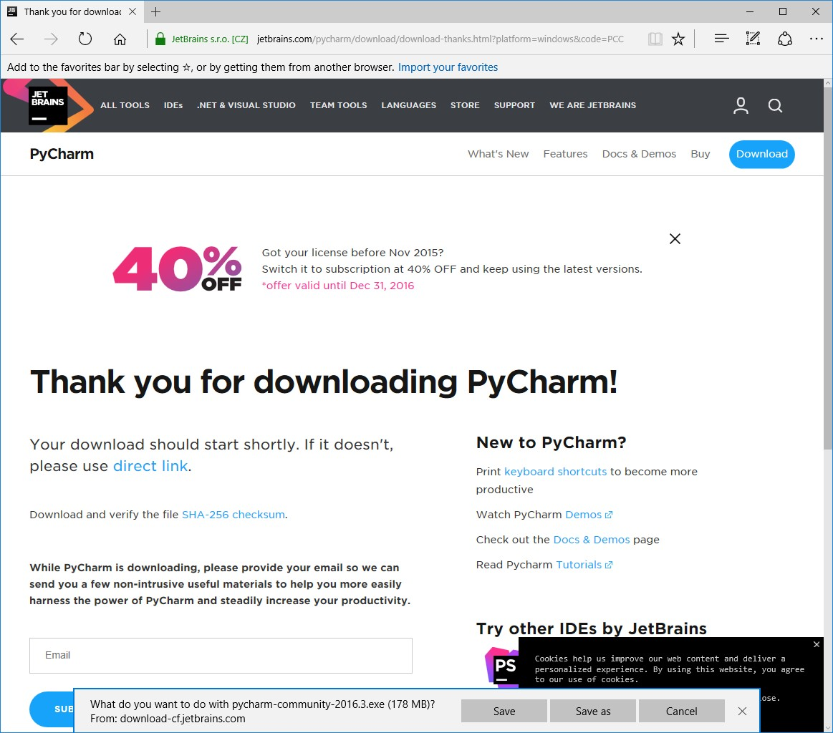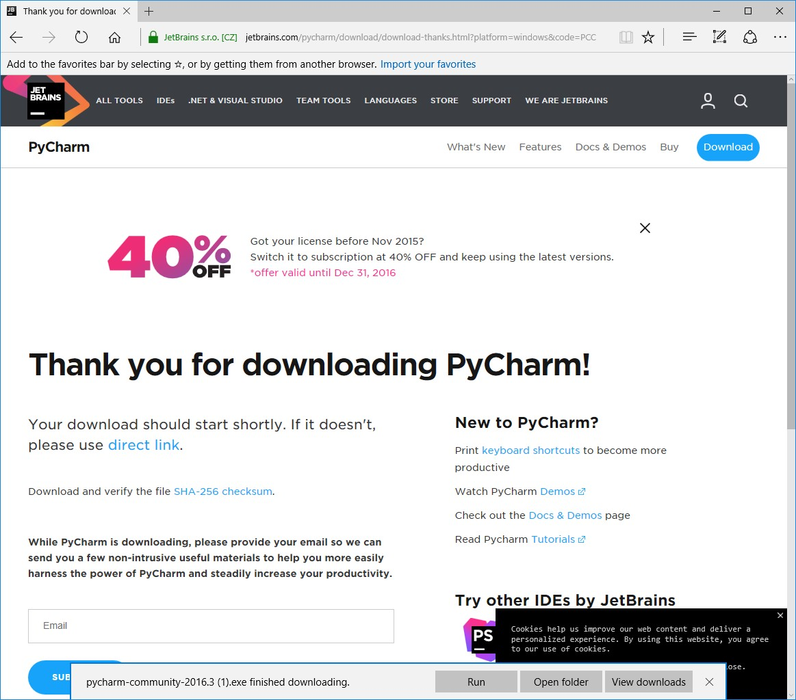

1. The setup wizard should have started. Click “Next”

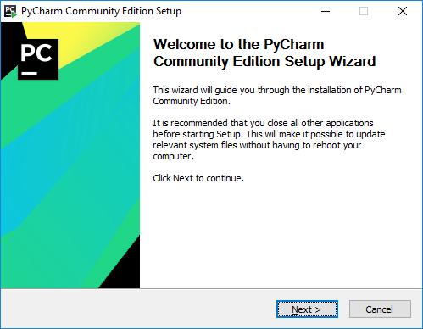

1. Choose an installation location. I recommend letting it install in the suggested location. Click Browse if you want to enter a new location, and when you are done selecting the location, click “Next”.

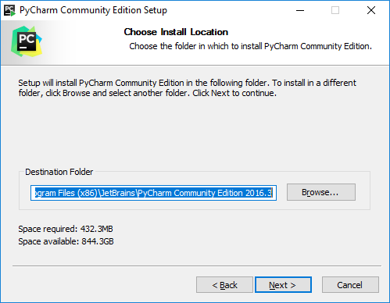

1. You can choose to select two options, after which you click “Next”
   1. You can create a desktop shortcut (I suggest doing so). This will put a link to PyCharm on your desktop.
   2. You can create associations (I suggest doing so). This means that when you open a python file (one with a .py extension), it will open in PyCharm

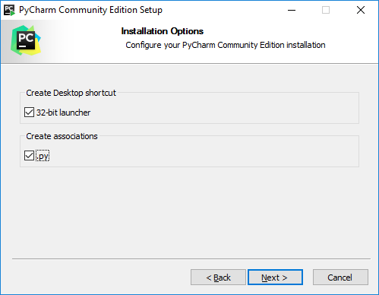

1. Choose a start menu folder (I suggest leaving the default “Jetbrains” selected, but you can change it if you wish) and click “Install”

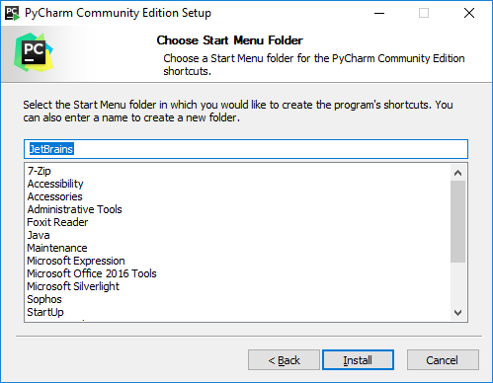

1. Wait for installation to finish. At the end, you should receive a message screen that PyCharm is installed. You

can click “Finish”, and if you want to go ahead and run it, click the “Run PyCharm Community Edition” box first. You have now installed PyCharm

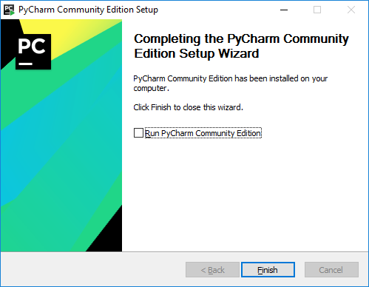

# Running PyCharm

1. The first time you run PyCharm, you will get a message box asking about importing settings. You can select “I do not have a previous version of PyCharm or I do not want to import my settings” and click “OK”

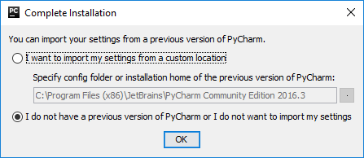

1. The first time you run PyCharm, you will need to accept the privacy policy.

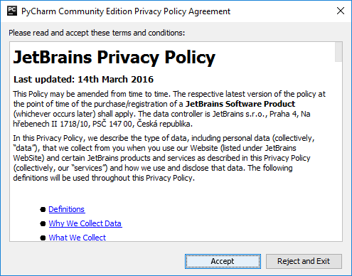

1. The first time you run PyCharm, you will have some “Initial Configuration” options. Just hit “OK”

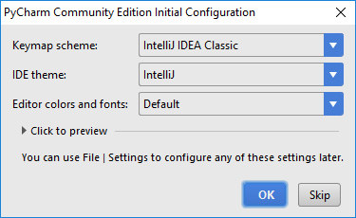

1. You will now be at the intro screen for PyCharm. This will also be the intro screen when you start PyCharm in the future without a recently opened project (if you do have a recently opened one you did not close before exiting, it will automatically reopen to that one). Click on “Create New Project”

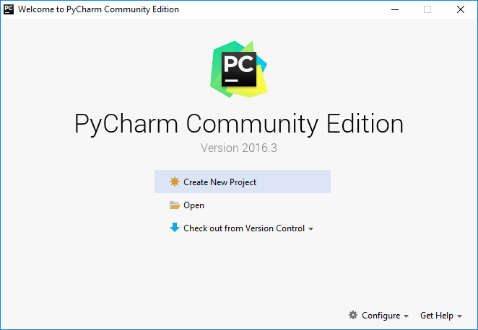

1. You will need to select a location.
   1. When it asks for the location, you can select where you want the project to be created. I suggest at least changing the name from “untitled” to something more meaningful, like “FirstProject”
   2. PyCharm should have found the Python interpreter you installed earlier (when you installed Python itself). It will be selected if so. **See TROUBLESHOOTING below for what to do if you do NOT have an Interpreter listed. If you do not have an interpreter listed, you need to resolve this before you can continue.**
   3. Click the “Create” Button when you have the project set up

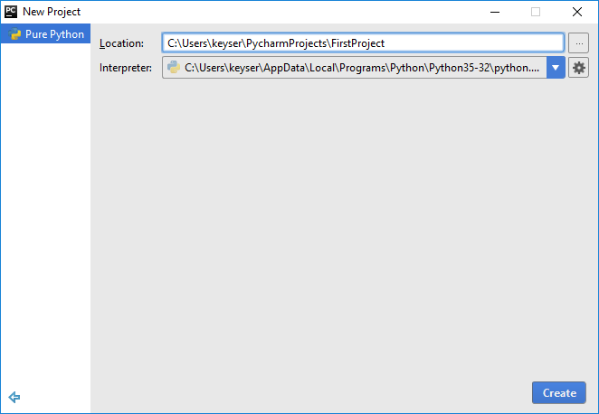

1. This will bring up the PyCharm environment (you can close the “Tip of the Day”) box that pops up

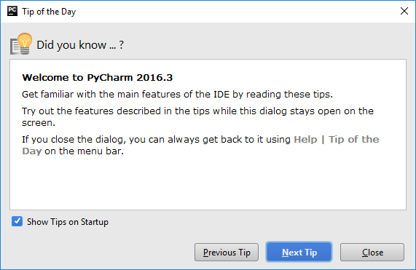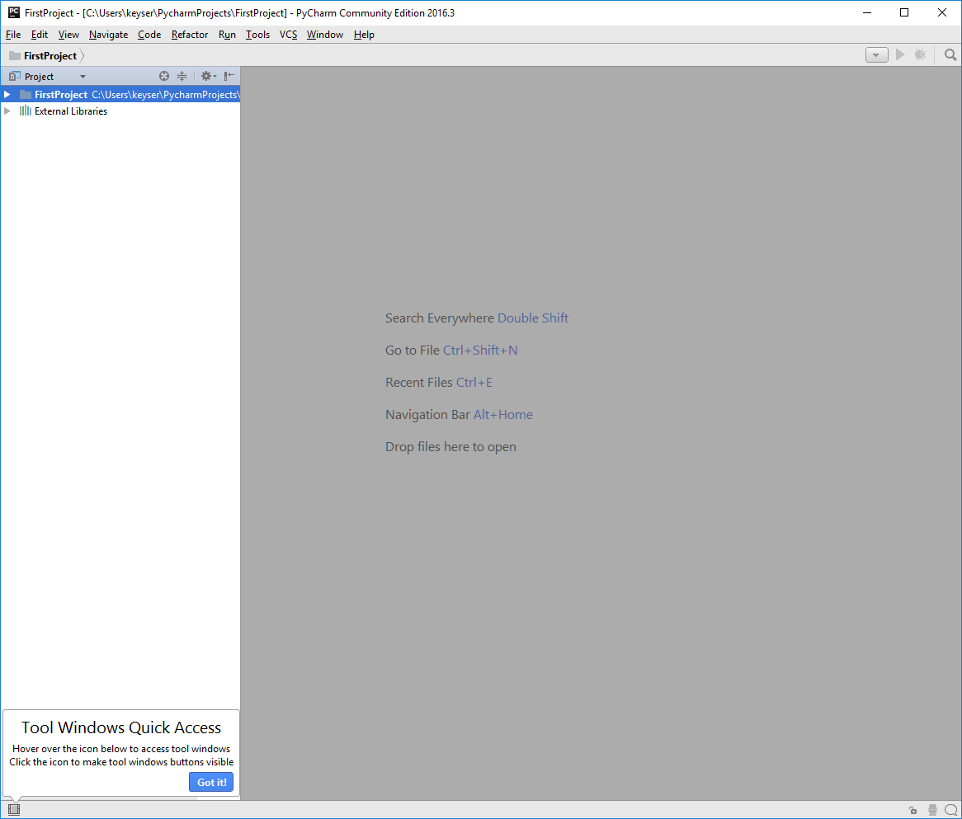

1. Try creating and running a program. Go up to the “File” menu and select “New”

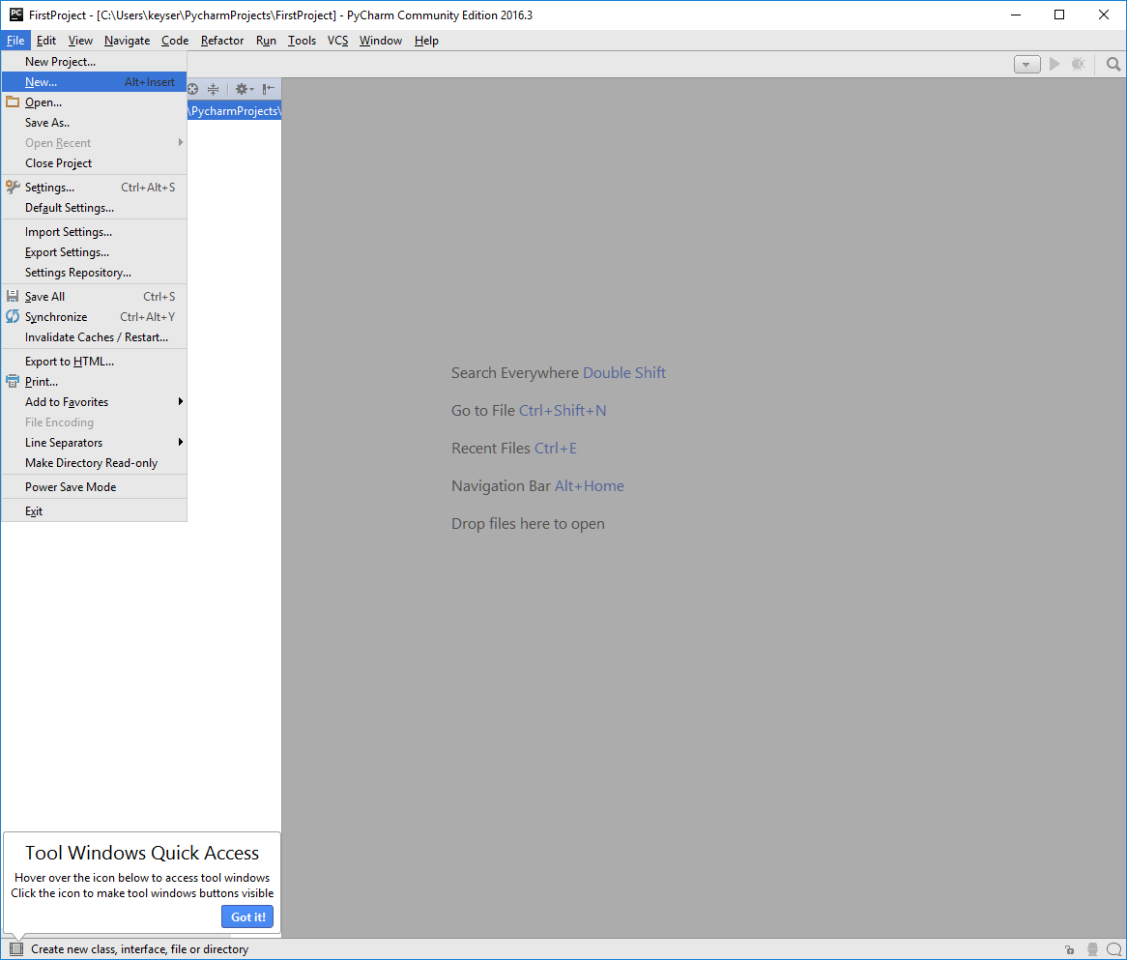

1. Select “Python File”

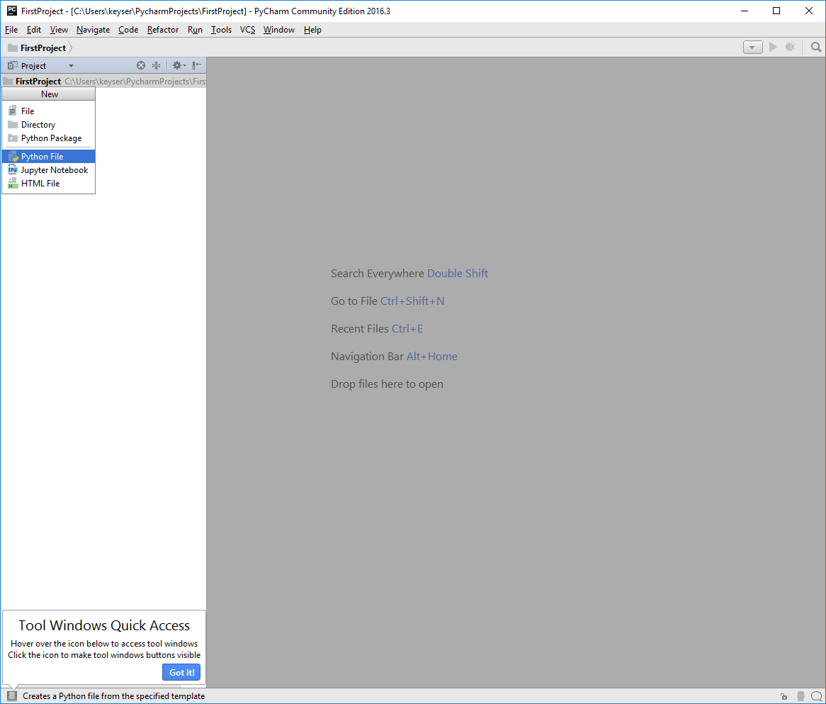

1. Type the name of the file you want (for example “FirstTest”) and hit “OK”

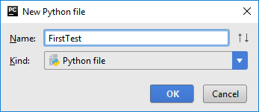

1. A new screen will pop up with the FirstTest.py file visible.

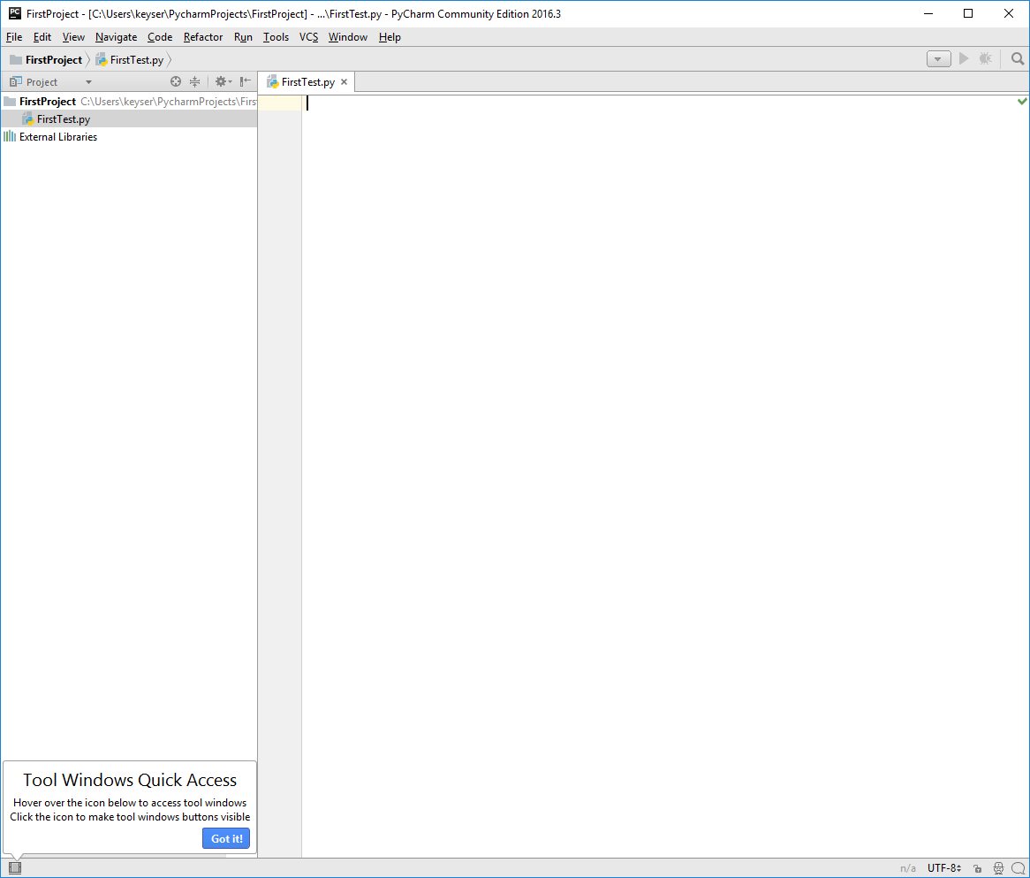

1. Go ahead and type in a simple program, like: print(‘Hello, World!’)

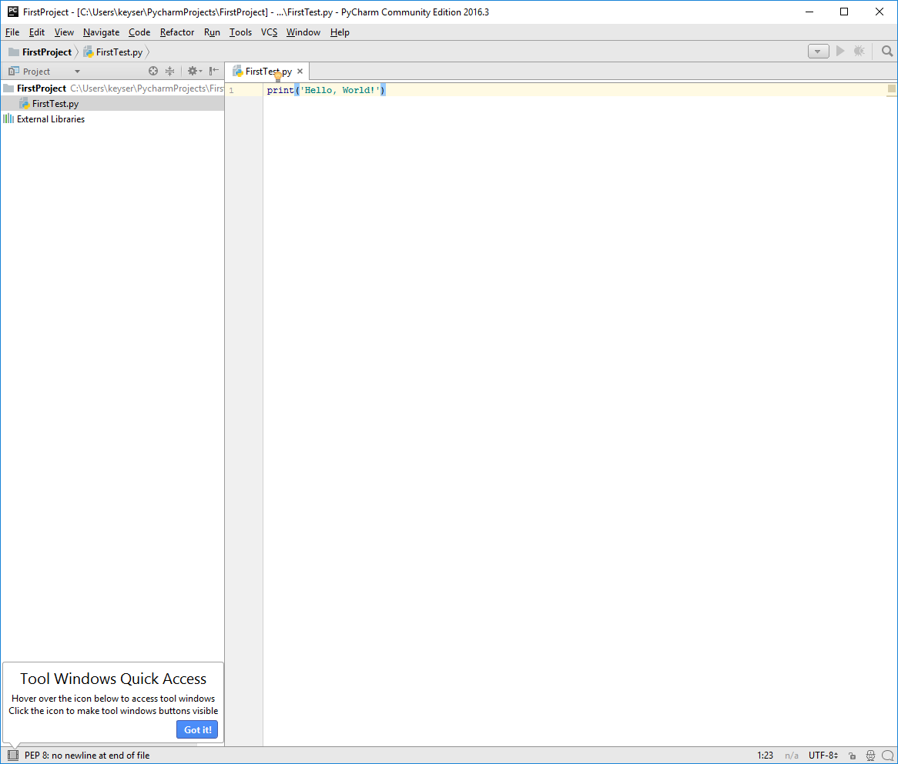

1. Go up to the “Run” menu and select “Run”(with the green arrow) to run your program:

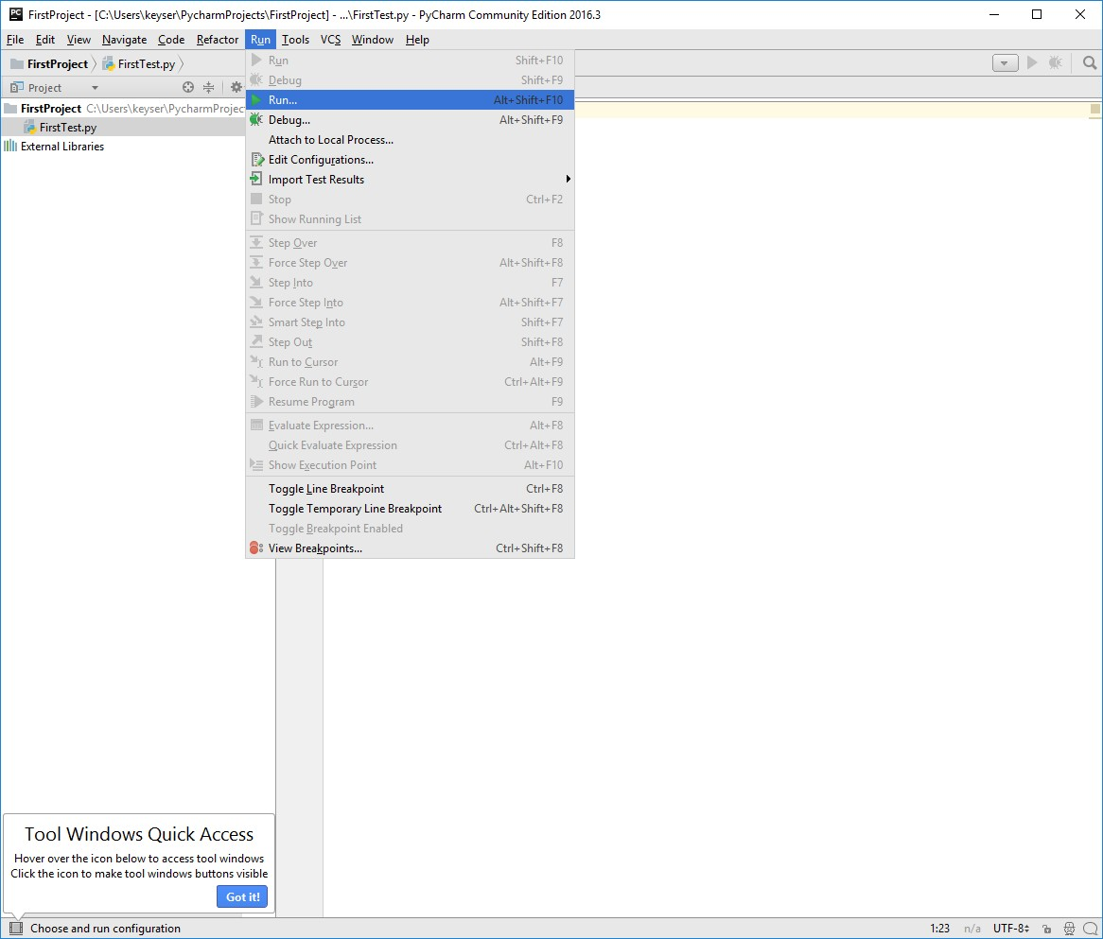

1. Select the name of your file that you will run (in the example, that’s “FirstTest”):

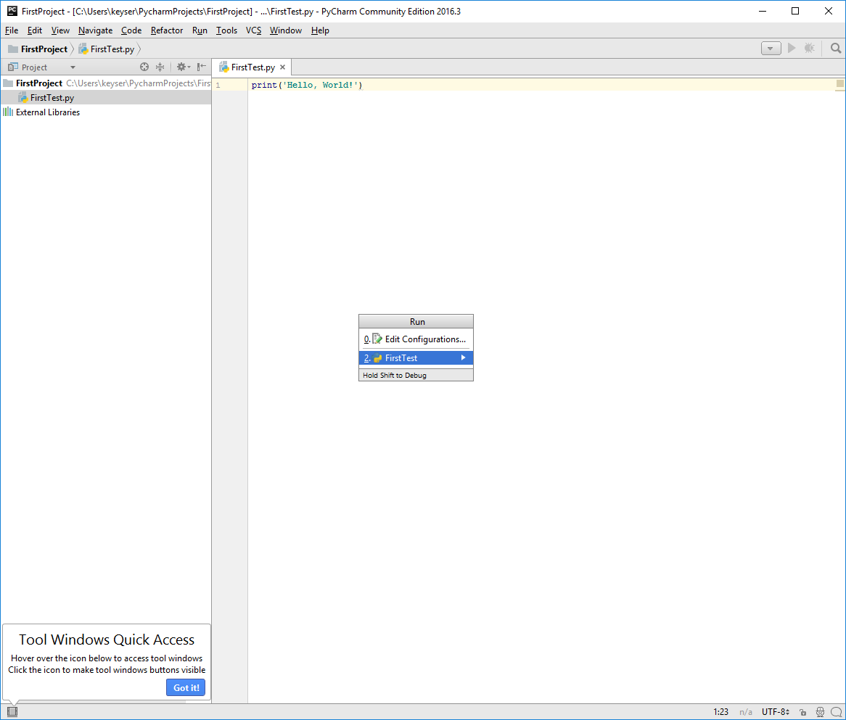

1. You should see the output of your program (in this case, the words Hello, World!, at the bottom of the screen:

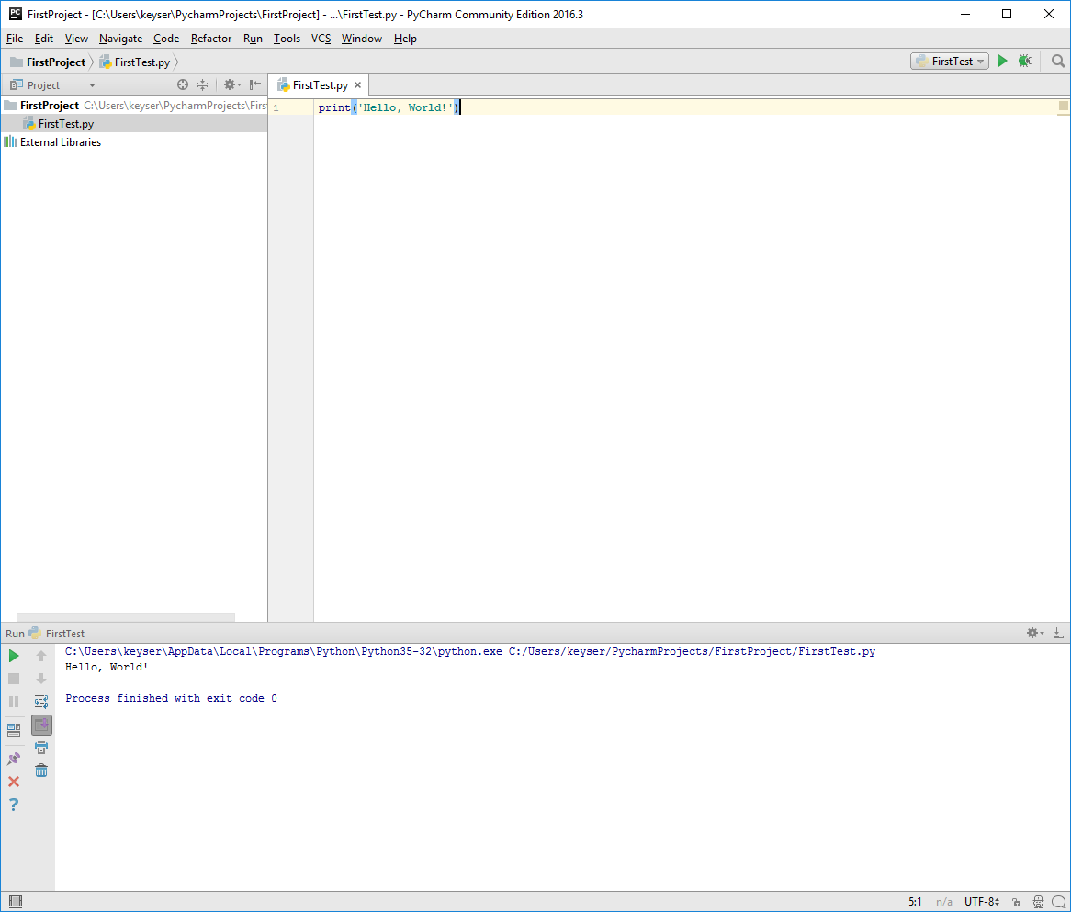

That’s all – you are ready to write programs using PyCharm.

# TROUBLESHOOTING:

**If you do NOT have an interpreter listed**, it means that PyCharm did not find a Python interpreter on your computer. You will see a window like this:

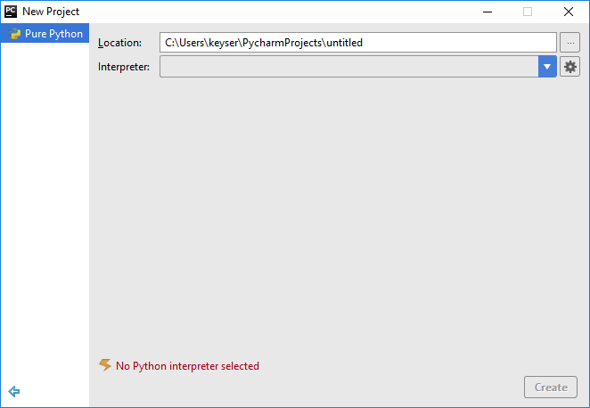

1. Did you install Python before installing PyCharm? If not, you need to go ahead and install Python! Close the PyCharm window and go back to do that first.
   1. You should make sure the installation completed and that you can run IDLE
   2. This is the most common reason that nothing is found. Once it is installed, go back and start PyCharm again, and it should find your Python interpreter.
2. If you are even slightly unsure if you installed it, try installing it again. If you have it installed already, you should get a screen like this when you try to install:

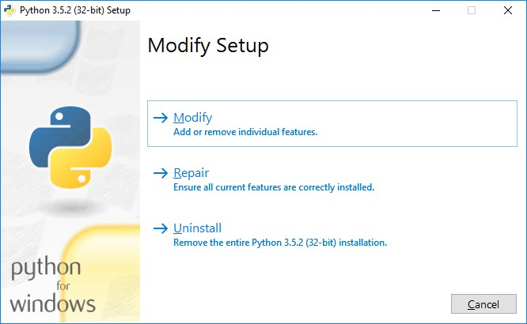

1. If you are sure you installed Python (and can test it by running IDLE), you will need to find the location where the python interpreter, usually named “python.exe” is installed. There are a few ways to do this:
   1. Try looking in a standard installation location, (where ***YOUR USER NAME** is your user name – mine is keyser for instance) like:

C:\Users\***YOUR USER NAME***\AppData\Local\Programs\Python\Python35-32\python.exe

* 1. If you noted the location when you installed Python (or you specified your own location), you should be able to note that, and use that location
  2. Do a search on your computer for python.exe:
     1. Open up the file explorer by typing “explorer” into the text box at lower left of your Windows system, and select File Explorer (not Internet Explorer)
     2. At the far left, click on “This PC” or “Windows (C:)”
     3. In the upper right, in the box labeled “Search This PC” or “Search Windows (C:)”, type “python.exe”
     4. There should be a file called “python” or “python.exe” found on your computer. That will be the one to use. Find the folder location for that file.
  3. If you can’t find it by any of these means, try to install Python again:
     1. When you first try to install, you should see the screen in (B), above.
     2. Choose “uninstall” and let it uninstall your current Python installation
     3. Then try to install, again. This time, choose “Customize Installation” when installing, and select a location you will be able to remember, such as C:\Program Files.
     4. If you reinstall Python, try restarting PyCharm to see if it finds the interpreter automatically; if not, you will know the location to tell it to look.

1. Once you know the location of your python interpreter, you will click on the little settings icon (that looks like a gear wheel) next to your “Interpreter” box. There should be a link saying “Add Local” that pops up when you do that – click on it.

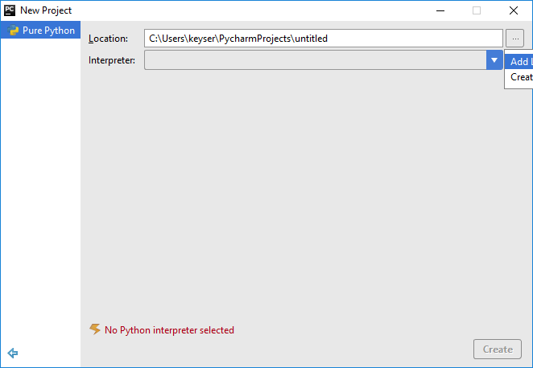

1. This will bring up a file navigation window. You will need to go to the location of your python.exe file.

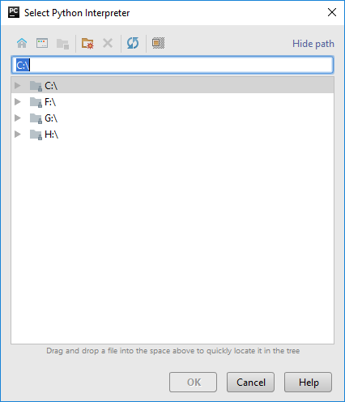

1. When you have selected the location of your python.exe file, hit “OK”

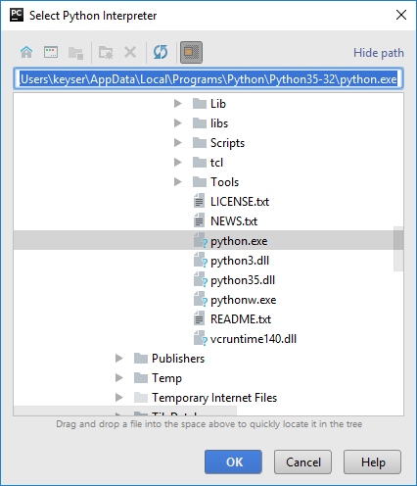

1. You are now OK to continue as above.